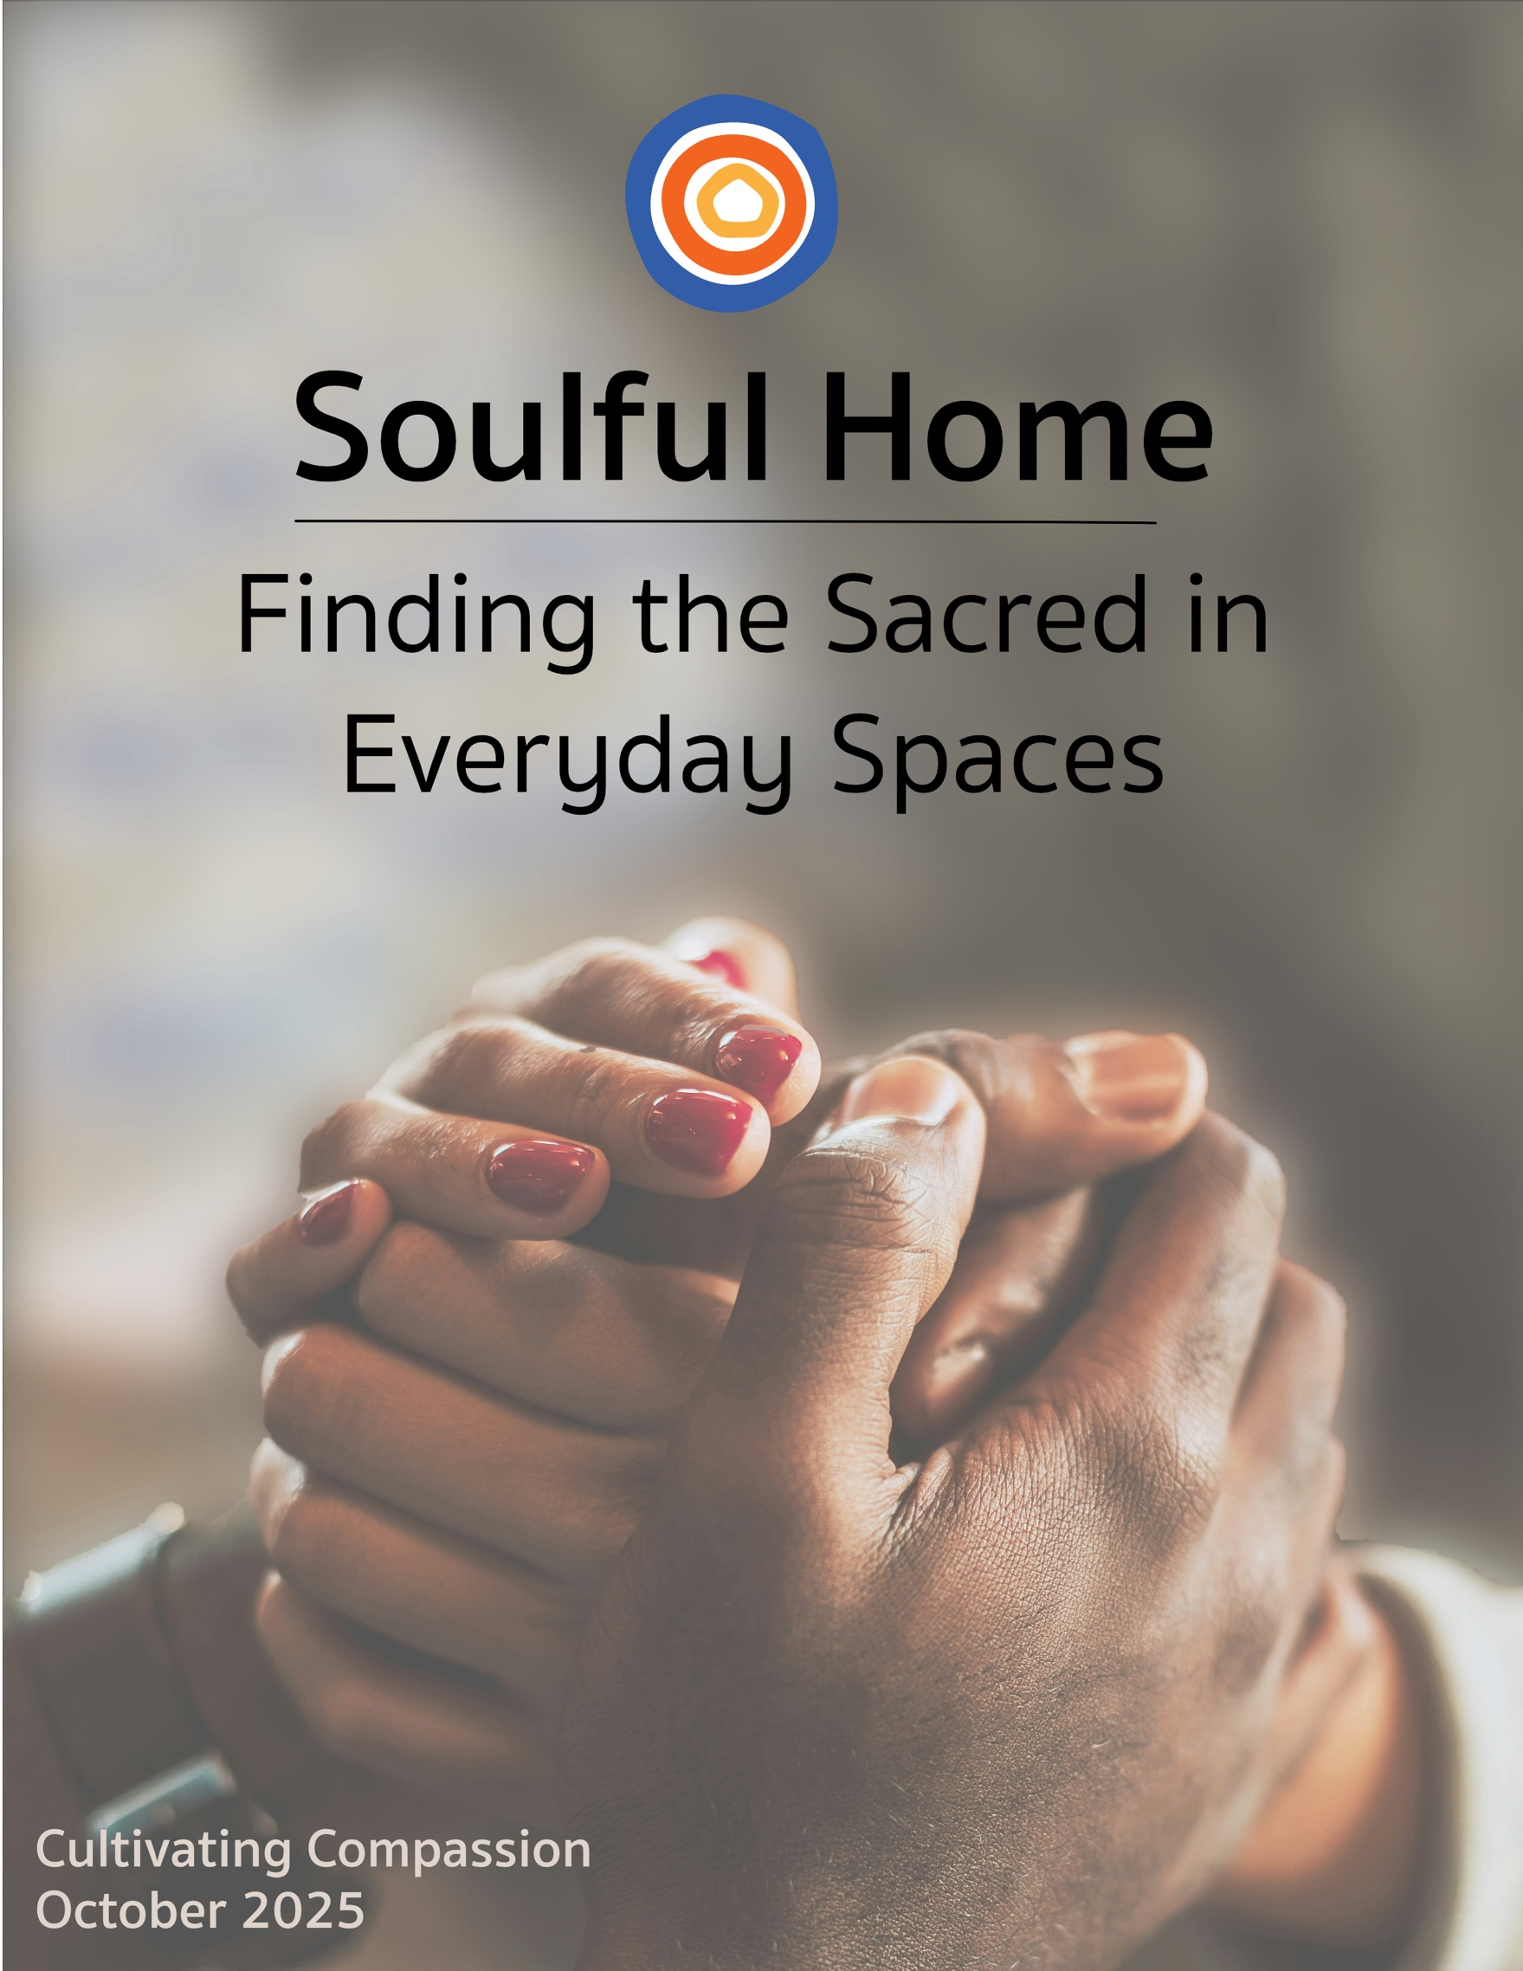

Table of Contents

The Welcome Mat
What Does it Mean to be a Family that Cultivates Compassion?

At the Table
Exploring Compassion Through Family Discussion

At Play
Playing With Compassion as a Family

At the Bedside and in the Book Nook
How to Be a Lion
Have You Filled a Bucket Today?
How to Help a Friend
Each Kindness
Wonder: Illustrated Edition

In Front of the Screen
Meet the Robinsons (G)
Iron Giant (PG)
Freaky Friday (2003) & FREAKIER FRIDAY (2025) (PG)
Arthur the King (PG-13)

In the Toolbox
How To Make Halloween Accessible to Families with Disabilities & Food Allergies
How to Help Your Child's Compassion Grow
How to Model Self-Compassion
Compassion, Self-Compassion, and Hope in Parenting

On the Porch
Connecting and Sharing Stories of Compassion with Your Village

Alongside the Chalice
52 Weeks of Compassion: A UU Family Spiritual Practice
Alternative (if 52 weeks feels like too large a task): The Tiny Compassion Challenge

The Extra Mile
Messenger of Compassion

Blessing
A Blessing of Compassion

The Welcome Mat

What Does it Mean to be a Family
that Cultivates Compassion?

When my kids were little, they would ask for a Band-Aid at every bump, bruise, scrape, and stubbed toe—whether it was bleeding or not. And to my surprise, I found myself peeling back the wrapper and pressing one over perfectly unbroken skin every time! I even went so far as to always have the character, camo, butterfly, and princess ones on hand - at home, in the car, in my purse, everywhere.

And here’s the thing: My Band-Aid habit was one of those things I said I would never do. Before I became a parent, that is. But parenting changes you, so I purchased the fun, extra-expensive Band-Aids and handed them out like they were oxygen. And every time I did, I marveled at how much comfort my babies found in those tiny strips of cartoon-covered plastic.

Why did I do this, you might be asking? Well, I did it because I realized I wasn’t just treating wounds. I was practicing something deeper. I was instilling a type of faith in my kids, a faith that their pain and wounds weren’t their own, a faith that their suffering wasn’t singular, but shared. I was cultivating in my children a trust that this is a compassionate world.

This simple act of “you get a band-aid, and you get a band-aid, and you get a band-aid” taught me that compassion doesn’t always look like fixing something. Sometimes it looks like noticing. Like stopping what you’re doing to tend to a feeling that may not make sense to us as adults, but is very real to a child. It looks like choosing kindness even when we’re busy, tired, or unsure.

All this is a way of saying that, at its heart, compassion is about showing up. It’s about making space for difference, tenderness, and connection. It’s about making room at the table—literally and metaphorically—for people who might be left out. It’s about recognizing that each person, no matter how small, carries heartache—and that we have a choice to tend to each other’s hurting hearts or turn away.

And so, as October reminds us that cold days are inevitably on their way, may we lead our families in this work of cultivating a more compassionate world. And may we remember that, just like those childhood Band-Aids, small acts of care offer more warmth than we know.

Blessed be,

April


At the Table

Exploring Compassion Through Discussions

The At the Table section engages the theme through question-driven family discussions. The questions are designed to be used at a family gathering, most often dinner, but also during a quiet moment in the living room, before a board game night, or while driving in the car. This section strengthens the bonds within a family as members learn more about each other by asking and answering evocative questions.

How To Go About It
The most straightforward way to do this is to have parents and/or caregivers read off the questions they think will resonate the most with family members and have everyone take turns answering. Another fun way to do this is to create a family question jar. To make this easier, we've listed all the questions below at the end of this packet with dotted lines you can cut along to make "question strips." You can then pull out the question jar and have family members choose a question/strip a few times each week.

Discussion Questions
- If compassion were a color, what would it be and why?
- Of all the fairy tale or storybook characters you’ve encountered, which is the most compassionate and why?
- Can animals be compassionate? If so, how do they show it?
- Can nature be compassionate? If so, how does it show it?
- Who’s a young person you know who is really compassionate? And who’s a grown-up you know who is really compassionate?
- Is it easier to be compassionate if you have everything you need or if you don’t? In other words, do our struggles help us be compassionate or do they get in the way?
- If a friend was upset because they lost a game, what might help them feel better?
- Have you ever had a hard time showing compassion to someone, even when you knew you should?
- Can people give themselves compassion?
- Can you feel compassion for someone you’ve never met?
- Are compassion and love the same thing? Why or why not?
- When you’re feeling compassion, what look is on your face?
- What is the difference between compassion and pity?

- Does showing compassion ever hurt?
- When was a time that compassion motivated you to do something really hard that you otherwise might not have done?

At Play

Playing With Compassion as a Family

At Play suggests games, crafts, and activities to help families experience the theme through joy and fun.

This Month's Treasure Hunt – Your Mission: Become a Compassion Detective!

This month’s hunt is for the greatest treasure of all: kindness and compassion! Your mission is to notice moments when people offer each other kindness, care, and help. There are so many places to look: at school, church, playgrounds, activities, stores, and home.

And here’s a secret: As you notice the compassion of others, you’ll be growing your own. Because when we pay attention to the kindness others show, we suddenly start to notice all the opportunities we have to be kind. This treasure hunt is also deeply connected to our Unitarian Universalist faith, which calls us to put love at the center of all we do.

To help you on your way, we’ve found a Compassion Detective Bingo Board. Take it with you whenever you can and when you spot someone showing compassion—big or small—check it off on the Compassion Bingo Board. See if you can find them all by the end of the month!

Directions
- Print the Compassion Detective Bingo Board (found at the end of this packet, Appendix A).
- Every time you see that act of compassion happen in real life, mark it off with a sticker, stamp, or colored dot.
- Celebrate as a family when you get a Bingo (five in a row) or Blackout (all squares filled).

Family Reflection
At the end of the month, gather as a family and share:
- What kind of compassion did you spot most often?
- Which was hardest to find?
- How did it feel to notice compassion all around you?
- Did you show compassion yourself after seeing others do it?


Additional At Play Options

Option A: “Compassion” Cookies

Nothing shows you care like sharing a sweet treat. Have fun baking as a family and make some “crumbly, melt-in-your-mouth heart-shaped thumbprint cookies filled with a fresh and fruity jam.” You can share them with your family or take it a step further and give some away to someone (or many someones) who needs a compassionate boost.

Find the recipe here

Option B: Kindness & Compassion Rocks

Paint rocks with uplifting messages or designs and hide them around the neighborhood for others to find.

Option C: Family Game Night That Puts Cooperation, not Competition, at the Center

Cooperative games are great ways to exercise compassion. When the goal is accomplished with everyone working together, players look at the circumstances of others around them to see how they can help, so that their shared endeavor succeeds. So gather the family (and friends) for a fun game night!
- Outfoxed: A Classic Who-Dunnit (5+)
- Magic Labyrinth: A Hidden Maze Memory Game (7+) - can be played competitively or cooperatively
- Castle Panic 2nd Edition: A Tower Defense Game(8+)
- So Clover! Cooperative Word Association Board Game (10+)
- Cooperative Puzzles – Work together to build a puzzle while listening to music or an audiobook.



At the Bedside and in the Book Nook
At The Bedside & In the Nook suggests books that help families engage the monthly themes with their imagination. This story-centered section honors the unique way stories enrich our sense of what's possible, expand our empathy, and build our identities.

How to Be a Lion by Ed Vere (suggested for kids 3-7)
An empowering example of an ever-compassionate friendship and acceptance.

Invitation to Connect: Parents, ask your children who among their friends offers compassion and acceptance.

How to Help a Friend by Karl Newson (suggested for kids 4-8)
This story introduces kids to the many ways to support their friends when they need it.

Invitation to Connect: Parents use this as an opportunity to talk with your kids about the ways they can offer compassion.

Have You Filled a Bucket Today? by Carol McCloud (suggested for kids 5-9)
“We “fill buckets” when we show kindness, appreciation, and love—small acts that lift others up and strengthen our connections. The story also reminds us that “bucket dipping”—unkind actions or words—can hurt, but they don’t define who we are. We can choose to repair harm, refill buckets, and even tend to our own.”

Invitation to Connect: Parents use this as an opportunity to talk with your kids about how compassion is both a gift we give and something we grow within ourselves.

Each Kindness by Jacqueline Woodson (suggested for kids 6-12)
This is not a “happy ending book.” But it does offer an important gift by helping upper elementary, middle grade, and perhaps some adult readers, too, navigate what to do when we miss an opportunity to be kind.

Invitation to Connect: Parents use this as an opportunity to talk about things like acceptance, bullying, consequences, making a good first impression, taking responsibility for your actions, feelings, and how all of this is part of being a compassionate person.

Wonder: Illustrated Edition by R. J. Palacio (suggested for kids 8-12)
“August Pullman was born with a facial difference that, up until now, has prevented him from going to a mainstream school. Starting 5th grade at Beecher Prep, he wants nothing more than to be treated as an ordinary kid--but his new classmates can't get past Auggie's extraordinary face… A #1 New York Times bestseller [that paints] a portrait of one community's struggle with empathy, compassion, and acceptance.”

Invitation to Connect: Parents, share this book with your kids as an opportunity to step into another’s shoes, see the world through new eyes, and talk together about kindness, empathy, and the courage to be yourself.


In Front of the Screen

Watching Meaningful Movies Together

In Front of the Screen offers families ways to connect with the monthly theme and each other through movies and TV shows.

Meet the Robinsons (G)
Snuggle up as a family and watch the story unfold as the quirky, big-hearted Robinsons warmly welcome a boy named Lewis into their lives, offering kindness and connection long before they know his true identity.

Invitation to Connect: Parents, use this movie as an opportunity to talk with your kids about what it means to welcome others, to believe in someone even when they’re struggling, and how small acts of care can change a life.

Iron Giant (PG)
Enjoy this moving story about an unlikely friendship between a young boy and a misunderstood robot.

Invitation to Connect: Parents, use this movie as an opportunity to talk with your kids about how compassion means seeing beyond fear, choosing peace over violence, and standing by those who are different even when it’s hard.

Freaky Friday (2003) & FREAKIER FRIDAY (2025) (PG)
An epic adventure unfolds when a mother and daughter swap bodies and have to literally walk a mile (or several) in each other's shoes, enabling them to have compassion for each other.

Invitation to Connect: Parents, use this movie as an opportunity to have a family discussion about what it really means to understand one another and how compassion grows when we pause to see life from someone else’s perspective.

Arthur the King (PG-13)
A great movie for older kids (12+), based on the true story of a stray dog who joins a team of adventure racers during a grueling race in the Dominican Republic. The team captain (played by Mark Wahlberg) chooses to help the injured, hungry dog—whom they name Arthur—despite the challenges it adds to their race.

Invitation to Connect: Parents, use this movie as an opportunity to have a family discussion. Here are some questions to get you started:
- Have you ever stuck with someone who’s struggling—even if it slows you down?
- When have you had to choose between winning and doing what feels right?
- Do you think compassion is a kind of strength?
- Are there times when we overlook others who need us?

- Why do some people or animals get labeled as "too much" or "not worth it"? How can we challenge those ideas in our families and communities?

In the Toolbox

Strategies to Help Our Kids and Ourselves Navigate the Complicated Stuff
In the Toolbox offers parents resources to better understand the well-established and newly emerging challenges of being a child today. It's all about equipping parents to be better guides and companions for their kids.

Resource One: The True Power of a Family Kindness Practice
https://www.doinggoodtogether.org/bhf/blog/power-of-a-kindness-practice
“My family of five has engaged in a weekly kindness practice for nearly five years, through toddlerhood, the birth of our third baby, and a major relocation…”

Resource Two: How To Make Halloween Accessible to Families with Disabilities & Food Allergies
https://theraplayoga.com/inclusive-halloween-tips/#:~:text=Originally%20intended%20for%20trick%2Dor,candy%20they%20can%20ACTUALLY%20eat.
“Halloween is a time of year when communities come together to PLAY- to celebrate the spooky, the fun”. But it is also a chance to offer compassion in the form of inclusivity! Children with disabilities and those with food allergies are often excluded from holiday events, such as trick-or-treating. This article offers lots of tips on how to be an accessible and inclusive trick-or-treating house this year.

Resource Three: Raising Kind Kids
https://greatergood.berkeley.edu/video/item/raising_kind_kids

Resource Four: How to Model Self-Compassion
https://www.childandfamilydevelopment.com/blog/how-to-model-self-compassion/
How to Model Self-Compassion for your kids: Changing the narrative from improving self-esteem to improving self-compassion



On the Porch

Connecting and Sharing Stories with Your Village

On the Porch uses thoughtful questions to open space for you and your parenting partners or parent/caregiver friends to connect more deeply with each other and think more deeply about how the monthly theme has shown up in your life and can show up in a more intentional way.

How to Go About It
Bring these questions with you when the time comes to hang out with your co-parent or parenting/caregiver buddy. Treat the questions less as a quiz and more like doorways inviting you into the world of mutual storytelling and memory. Go through them all or pick a few that call to you most.

Questions

- What did watching your parents teach you (or not teach you) about compassion? How about self-compassion?
- What has your experience as a parent or caregiver taught you about compassion in the last three months?
- When has raising children stretched your capacity for compassion?
- How do you show yourself compassion when you feel like you're falling short?
- What does "putting love at the center" mean in your parenting, especially in moments of conflict or stress?
- How good are you at teaching your children compassion through your actions?
- When your child is acting out, what helps you respond with empathy instead of frustration?
- How do you balance compassion and boundaries with your child?
- If you could go back in time and bring more compassion to the moment of parenting, what moment would that be?
- When do you most need compassion as a parent or caregiver?
- What would the features of a “compassionate community” be? What would it feel like to live there?
- If you could only pass on one piece of wisdom about self-compassion to your child(ren), what would it be?
- What has compassion moved you to sacrifice?
- How has compassion strengthened you?



Alongside the Chalice

Family spiritual practices and rituals are crucial for kids, youth, and adults. While lighting a chalice at home is a beautiful family practice, it can often be the only explicit UU identity practice we bring into our homes. So our Alongside the Chalice section offers a different UU practice, observance, or ritual for families to try out each month, with the hope that a few stick and become woven into the repeated and treasured rhythms of family life.

A Month of Compassion: A UU Family Spiritual Practice

“Let love be the spirit of this family.”

Unitarian Universalism calls us to put love at the center of all we do. Practicing compassion—toward ourselves, each other, our communities, and the world—is one way we live our faith every day. This spiritual practice invites your family to deepen that commitment, one act at a time. Each day (or every few days), your family will draw one prompt from a jar. Each slip invites you to notice, act, and reflect—to open your heart a little wider and strengthen your capacity to live with compassion. Let this be a rhythm in your home—a shared practice of attention, kindness, and love in action.

- Prepare a Compassion Jar
Print and cut out the prompts (found at the end of this packet, Appendix B), fold them up, and place them in a jar or basket labeled: “This family practices compassion.”
- Choose a Weekly Time
You might draw your weekly prompt during a shared meal, at bedtime on Sunday, or as part of your regular family ritual.
- Light a Chalice
Use this moment to center yourselves. You might say:
“We light this chalice for love, for compassion, and for all the ways we can care for others and ourselves.”
- Read the Prompt Together
Talk about what it means and how you might live it out in the coming days.
- Live the Practice
By making compassion a regular part of your family’s spiritual life, you nurture both faith and action, helping each family member grow in love, courage, and awareness.
- Reflect at Week’s End
Return to the chalice, and ask:
  - What did we learn this week?

  - How did this help us put love at the center?

Alternative (if a month feels like too large a task):

The Tiny Compassion Challenge
During the weeks to come, challenge your family to be compassionate people who look for opportunities to be empathetic. As UUs, not only do we train our hearts to be compassionate, but we look for ways to actively answer compassion’s call to show up in both tiny and big ways.

Directions

1. Find It - “Eyes of Kindness”
Each morning, pause for ten seconds and quietly ask yourself,
“Who might need a little kindness today?”
Look around—at school, home, the playground, or online—and notice one person who might be feeling left out, rushed, nervous, or unseen.

2. Choose It - “Pocket‑Size Acts”
Pick one tiny act you can carry out that day. Keep it simple:

Pocket‑Size Acts How It Ripples
Flash a genuine smile Lifts a mood, invites connection
Offer a sincere compliment Reminds someone of their worth
Hold the door or share supplies Eases another’s stress
Invite a classmate into your game Breaks down loneliness
Write a quick thank‑you note Spreads gratitude further

3. Do It - “One Step, One Smile”
Carry out your tiny act. No fanfare, no selfies—just quiet care.
Remember: big change begins with one small motion, just like a single pebble starts many ripples.

4. Log It - “Ripple Record”
At day’s end, jot a sentence or draw a picture on an index card:
- Who did you help?
- What did you do?
- How do you think it might ripple outward?

Bring your cards back next session to hang on our Ripple Wall. Watching the wall fill up shows how many waves of kindness our group can make in just one week.

5. Reflect It - “Heart Check‑In”
At the end of the month, read your records as a family and ask:
- Which act felt easiest? Which felt hardest?
- Did you notice any new hurts you’d never seen before?
- How did practicing tiny compassion change your mood?

- Optional journal prompt: “When I notice small hurts, I can… ”

The Extra Mile
The Extra Mile section is for families who want to continue exploring the theme of the month through larger adventures, more complex projects, or simply through additional modalities not otherwise included in the packets. A bit more effort, but well worth it!

Messenger of Compassion
A spiritual practice of connection and kindness inspired by UU educator Kimberly Sweeney

Back in 2015, UU religious educator Kimberly Sweeney shared a joyful, heart-healing spiritual practice she began during a long, gray New England winter. She felt a little low, tired of being cooped up, missing her friends, and longing for the warmth of connection. So she decided to send magic into the world. How? With letters. But not just any letters—magical messages of compassion.

She started writing clever, colorful, unexpected notes and mailing them to people she cared about. They were filled with joy, surprise, love, and compassion. And they reminded both the writer and the reader that we’re never truly alone.

Your Messages of Compassion
Imagine your home as a lighthouse—beaming out warmth to others, one letter at a time. You can send messages of compassion to:

- Friends
- Grandparents or cousins
- Someone from your congregation
- A teacher or coach
- A neighbor
- A stranger who might need a little joy (like a letter left on a community board or in a free library box!)

Add a Little Magic
Challenge yourself to include at least three of the following surprises in your letter:

- A letter written with each sentence in a different color
- A note that begins with the words: “Thank you…”
- A drawing
- A silly photo of yourself
- Confetti tucked into the envelope
- A homemade bookmark
- A string of paper dolls or other handmade decoration
- A riddle, joke, or small surprise for the reader

- A favorite memory you’ve shared with the recipient

Blessing of Compassion

Dear bear huggers, band-aid handers, bad-dream snugglers, and kindness spreaders,

May your hearts open wide, and your hands be gentle, ready to heal and hold those with hurting hearts.
May your eyes see beyond differences to the shared light inside
each person.
And may you journey steadily on the paths of empathy, helping others carry their burdens and celebrate their joys.

May you honor the earth beneath your feet and all the creatures
that call it home.
May your family live in harmony with all beings, protecting and cherishing this sacred planet we share.

May you remember to be kind and compassionate to yourselves,
For our children do not need perfect parents, but only parents doing their best with love.

May your family be rooted in love and guided by our UU values.
May you grow together, choosing connection over division and compassion over fear.
And may your home be a sanctuary where all feel safe, seen, and deeply loved.


Blessed be, and may it be so.

~ April Rosario

Question Jar Cut-Outs
We invite you to write your own questions as well
We also remind you that questions that evoke stories are often the most impactful.

What did watching your parents teach you (or not teach you) about compassion? How about self-compassion?

What has your experience as a parent or caregiver taught you about compassion in the last three months?

When has raising children stretched your capacity for compassion?
How do you show yourself compassion when you feel
like you're falling short?

What does "putting love at the center" mean in your parenting, especially in moments of conflict or stress?

How good are you at teaching your children
compassion through your actions?

When your child is acting out, what helps you respond with empathy instead of frustration?

How do you balance compassion and boundaries with your child?

If you could go back in time and bring more compassion to the moment of parenting, what moment would that be?

When do you most need compassion as a parent or caregiver?
What would the features of a “compassionate community” be? What would it feel like to live there?

If you could only pass on one piece of wisdom about self-compassion to your child(ren), what would it be?

What has compassion moved you to sacrifice?

How has compassion strengthened you?

Appendix A

This Month's Treasure Hunt

Your Mission: Become a Compassion Detective!

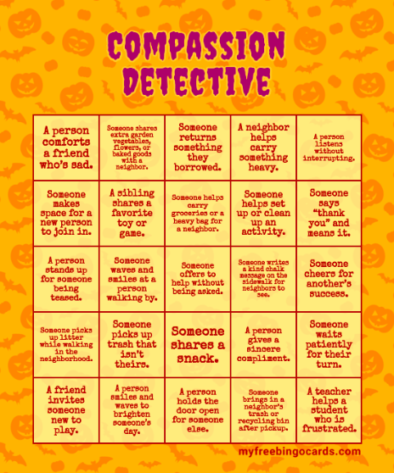

Appendix B

A Month of Compassion: A UU Family Spiritual Practice

“Let love be the spirit of this family.”

- Bring hot cocoa to a neighbor

- Leave a treat for the mail carrier in your mailbox

- Give some flowers to someone feeling unwell

- Make happy notes on the sidewalk with chalk

- Organize an afternoon of games for your neighborhood

- Take ice water and cups to the playground to share with others

- Hold a Lemonade Stand to donate to a cause you support

- Rake leaves (or do gardening) for a neighbor

- Take snacks to the staff at the local Hospital

- Babysit so that a couple can have a date

- Donate toys to the fire brigade for children in emergencies

- Read inspiring stories to a group of children

- Donate books to a doctor’s or dentist’s office

- Take a treat to a bus driver

- Invite another family over for dinner

- Take a Thank You card to the local librarians

- Draw a picture of your community for the Police Station

- Open the door for people entering a shop or restaurant

- Bring a meal to a family in need (recent birth, sickness, or loss)

- Write a poem for someone you love

- Make “Be Happy” notes and put them in mailboxes

- Learn a joke to tell to a check-out person

- Tape change to a parking meter or vending machine

- Make a list of things you love about someone and send it to them

- Leave a happy note in a library book

- Send a postcard to a distant cousin or friend who moved away

- Pick up trash around the neighborhood or at a park

- Sing for the elderly

- Go on an errand and smile at everyone you see

- Blow bubbles (and take extra) to the playground

- Volunteer in a local animal shelter

- Take cans of food to the local Food Bank

- Donate old clothes to a local organization

- Let someone go ahead of you in line at the shops

Connect With More Inspiration

For You and Your Family!

Parents can join our Facebook and Instagram pages for
daily Inspiration on our themes:
Facebook: https://www.facebook.com/soulmatterssharingcircle/?ref=settings
Instagram: https://www.instagram.com/soul_matters_circle/

Parents and youth will want to check out
our Spotify & YouTube music playlists on the monthly themes.

Credits
Soulful Home packets are prepared by
April Rosario,
Our Soul Matters Director of RE Resources and Family Ministry Coordinator

You are free to use any of this material verbatim in worship, newsletters
or similar contexts, with attribution to April Rosario.


© 2025-2026 Soul Matters ALL RIGHTS RESERVED
Packets are for use only by member congregations of and individual subscribers
to the Soul Matters Sharing Circle.
Learn more about subscribing on our website:
https://www.soulmatterssharingcircle.com/soulful-home.html

