
UUSS BOARD OF TRUSTEES MEETING
Thursday, September 25, 2025, 6:30 p.m., via Zoom and in person
MINUTES

Present in person: Andy Cramer, Carl Crain, Dawn Huebner, Mathew Espinso-Castro,
Emily Moran-Vogt, Rev. Lucy Bunch, Rev. Dr. Roger Jones, Sophia McKean, Fred Pannek
Present on Zoom: Janet Lopes, Patty Innes, Victoria Owens
Guest present in person: Mags Matthews

6:32 Andy welcomed members and guests, Janet read the opening, and Roger lit the chalice.

6:35 Andy welcomed UUSS member Mags Matthews, who spoke to the Board about her experiences as a newcomer at UUSS, and her thoughts on ways to make UUSS a more family-welcoming congregation.

6:48 Board approved August minutes

6:49 Board Business
- Board member replacement: Andy nominated Carl Crain to fill the Member-at-Large open term. A motion to appoint Carl to the Board was offered, seconded, and approved by the Board.

- New calendar demonstration: Rev. Lucy reported that Staff continues to refine the calendar, and demonstration to the Board will be on the October agenda.

- Safety Committee Vetting procedure: Andy stated that one of the primary Board goals this year is to reconstitute the Safety Committee. First step in this process is to develop a vetting and recruiting process for Safety Committee members. The Board approved the formation of a Safety Committee task force led by Patty Innes with Emily Moran-Vogt and Rev. Dr. Roger Jones.

- Stewardship 2026/2027 goal: Andy outlined the Board’s responsibility in providing guidance to the Stewardship Committee in setting the 2026/2027 pledge drive goal. The Board discussed staffing opportunities that would require additional funding. Andy noted that board will need to provide a goal to Stewardship by December.

- Board Goals (Staffing plan): Andy addressed the goal of developing a staffing plan that is aligned with the Strategic Plan. Rev. Lucy stated the first step was to review current staffing, evaluate staffing gaps and opportunities to fulfill the Strategic Plan. Rev. Lucy identified areas to be considered for staffing opportunities: member engagement, communications, social justice work and family ministry. A motion to create a Staffing Plan Task Force was offered, seconded, and approved. Rev. Lucy Bunch, Andy, Victoria, and Sophia agreed to serve on the task force. The Board would like the task force to include a Program Council representative, and several congregation members were identified as possible task force members. Andy will reach out to the Program Council.

- Fall Congregational Meeting Planning: A draft agenda for the October 19th Congregational Meeting was reviewed, tasks assigned, and the agenda was finalized, and shown below. A Congregational Meeting Packet will be prepared and posted on the website, and links to the packet will be included in the Leadership Message, and monthly calendar. Groups that will use slides during the Congregational Meeting will need to submit the material to the Secretary no later than October 12, 2025.

8:08 Task Force Updates
- Website Replacement: Mathew presented a Website Redesign Task Force – Scope of Work document, detailing each step of the website redesign over a 12-month period. The Task Force will develop a Request for Proposals (RFP), select a contractor for Board approval, and manage the project. Contractor selection criteria will include usability, accessibility, content management, and long-term maintenance. The Task Force will gather input from the congregation throughout the process. The Board asked Mathew to form the Task Force. The Scope of Work is shown below.

8:31 Administrative Report: Rev. Lucy Bunch stated the staff continues to work on and refine the new calendar. Lucy advised that Room 12 makeover has been completed. Board members noted appreciation for the new calendar.

8:34 Treasurer’s Report: Victoria submitted a written report, which included expanded explanation of the four Funds. Victoria reported that items related to budget surplus, which were approved by the Board in August, would be reflected in the September report.

8:38 Ministers’ Reports – Rev. Roger Jones / Rev. Lucy Bunch provided a written report.

8:40 Committee Substantive Issues, if needed
- Memorial Wall: Dawn updated the Board on the work of the Memorial Wall Committee and submitted a written report.
- APMC (Administration and Property Management): Fred reported that having served over 10 years as Kitchen Manager, Glory Wicklund was stepping down. The Board will express our gratitude to Glory for her service.
- Social Justice Coordinating Council: Andy submitted a written report.

8:50 Recap board decisions from September BOT for October Monthly Leadership Update:
      - Announce new Board member.
      - Announce Website Task Force
      - Express Gratitude to Glory Wicklund
      - Congregational Meeting, including link to packet.
      - Welcoming ministerial intern, Sophia McKean

8:54 Closing: Janet, meeting adjourned.

Next Meetings:
- Executive Committee Meeting (via Zoom): Tuesday, October 14, 5 PM
- Board Meeting (via Zoom & in person): Thursday, October 23, 6:30 PM

Board Events | Date
Fall Congregational Meeting | 19-Oct-25
Auction | 11/8/2025
Recruit - GA Delegates | 1/1/2026
Budget/Review of contracts, letter of intent | 3/1/2026
Stewardship Campaign | 3/1/2026
Spring Congregational Meeting | 5/17/2026

UUSS Congregational Meeting - via Zoom and in-person
Sunday, October 19, 2025, at 11:45am
AGENDA
- Welcome — Andy Cramer (2 min)
- Establish Quorum— Andy Cramer (2 min)
- Invocation and Chalice Lighting — Rev. Dr. Roger Jones (3 min)
- Review agenda and meeting procedures — Andy Cramer (2 min)
- Approve May 2025 Congregational meeting minutes (3 min)
- President’s Report — Andy Cramer (7 min)
- Treasurer's Report — Victoria Owens (7 min)
- Ministers Report— Rev. Dr. Roger Jones (7 min)
- Program Council Report — Sean Fountain (7 min)
- Community Partners Proposal- Fred Pannek (5 min)
- Community Partners vote (5 min).
- UUSS Unsung Hero Award —Program Council (5 min)
- Closing —Rev. Dr. Roger Jones Minister (3 min)

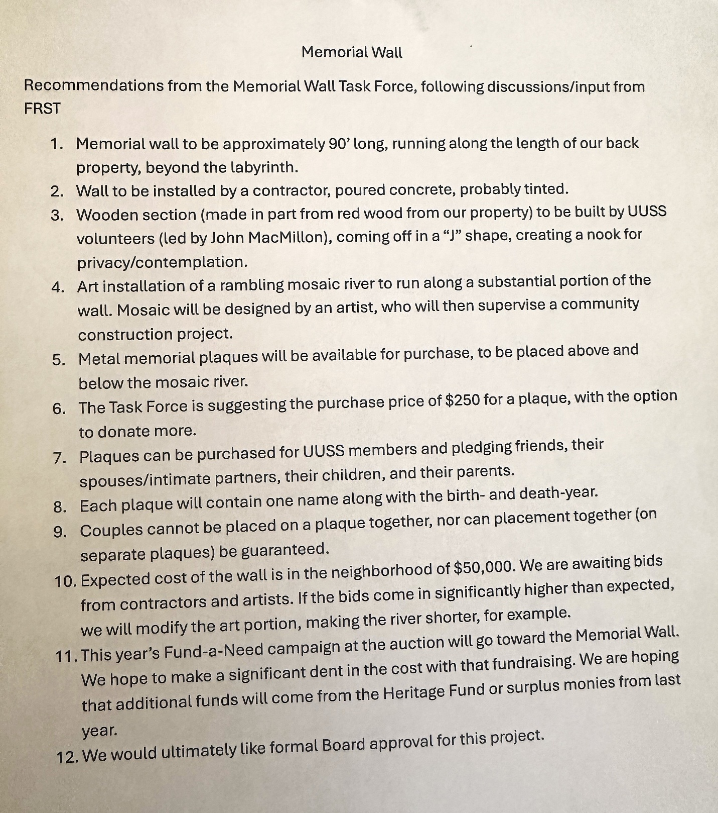

Website Redesign Task Force – Scope of Work

Mission of UUSS
We come together to deepen our lives and be a force for healing in the world.
UUSS is a covenantal, intergenerational community traveling together with open minds, open hearts, and helping hands. We value justice, compassion, integrity, acceptance, spiritual growth, learning together, caring, and laughter. We welcome diversity in religious perspective, gender identity, sexual orientation, cultural and ethnic background, family structure, citizenship or immigration status, and promote inclusivity in all aspects of congregational life.

Purpose and Goals of the Website Redesign Task Force
The Website Redesign Task Force will guide and oversee the process of selecting and working with a qualified contractor to redesign the UUSS website. Its primary goals are:
Develop a Request for Proposals (RFP) outlining UUSS’s requirements, priorities, and expectations.
Establish transparent criteria for evaluating contractor proposals (experience, cost, accessibility expertise, design approach, timeline).
Review contractor proposals and recommend a contractor to the UUSS Board of Trustees.
Provide feedback to the contractor on site architecture, design mockups, branding, and functionality.
Ensure the new website reflects UUSS’s mission, covenant, and values while improving usability and accessibility.
Support the launch and transition by reviewing final deliverables, training, and documentation.

Membership
The Task Force should include a balance of representation across leadership, staff, expertise, and interested congregation members:
At least one member of the UUSS Board of Trustees
At least one member of the Program Council
Relevant UUSS staff (communications, IT, administrative)
Congregation members with interest/expertise in communications, design, user experience, web development, or related areas
Current Proposed Membership
Role | Name
Task Force Lead  Board Member | Mathew Espinosa-Castro
Board Member | Janet Lopes
PC Member | Sean Fountain
UUSS Staff
Congregation Member | Michael O'Neill
Congregation Member | Peter Bishop
Congregation Member | Jennifer Webb
Congregation Member | Judy Lane
Congregation Member | Marlaina Rodriguez
Congregation Member | Dawnabelle Rodriguez

Scope of Work

Phase 1: Discovery & RFP Development
• Review current website strengths and challenges
• Gather input from staff, leadership, and key stakeholders
• Draft and finalize RFP
• Develop contractor selection criteria
Deliverables: RFP document, selection criteria

Phase 2: Contractor Selection
• Issue RFP and invite proposals
• Review proposals against criteria
• Conduct interviews or presentations if needed
• Recommend contractor to Board
Deliverables: Proposal review summary, recommended contractor

Phase 3: Contractor Onboarding & Design Oversight
• Meet with contractor to confirm scope and timeline
• Review and provide feedback on site architecture, design mockups, and branding
• Ensure accessibility, usability, and mobile standards
Deliverables: Feedback memos/reports, approval of design milestones

Phase 4: Development & Testing Oversight
• Review contractor’s progress at key checkpoints
• Provide feedback on draft builds and content migration
• Participate in usability and accessibility reviews
• Approve readiness for launch
Deliverables: Feedback to contractor, approval for launch

Phase 5: Launch & Transition Support
• Support communication to the congregation about the new site
• Review training materials and documentation
• Confirm staff/volunteer readiness for maintenance
• Conduct post-launch review
Deliverables: Launch communication plan, post-launch feedback summary

Proposed Timeline (12 Months)
Phase | Duration | Milestones
Phase 1: Discovery & RFP Development | 3 months (Months 1–3) | Stakeholder input, draft/finalize RFP, approve criteria
Phase 2: Contractor Selection | 2 months (Months 4–5) | Issue RFP, review proposals, recommend contractor
Phase 3: Contractor Onboarding & Design Oversight | 3 months (Months 6–8) | Kickoff, review site architecture, design feedback
Phase 4: Development & Testing Oversight | 3 months (Months 9–11) | Review builds, usability/accessibility testing, approve launch
Phase 5: Launch & Transition Support | 1 month (Month 12) | Launch, communications, training, post-launch review

Criteria for a High-Quality UUSS Website

Mission & Values Alignment
Communicates UUSS’s mission and covenant clearly
Reflects inclusivity, diversity, and UUSS values
Welcoming tone and imagery that reflect community diversity

Usability & Accessibility
Meets WCAG 2.1 AA standards
Easy navigation, consistent layout, and mobile responsiveness
Readable typography and strong color contrast
Effective site search

Content & Communications
Up-to-date worship, event, and program information
Clear visitor pathways ('I’m new here', FAQs, directions)
Prominent and easy-to-use donation and pledge options
Integration with calendar, newsletter, and event registration
Consistent style and removal of outdated content

Design & Branding
Modern, uncluttered, and welcoming design
Consistent colors, fonts, and branding
Visual storytelling with photos and videos
Home page designed for both newcomers and members

Functionality & Integration
Integration with donations, email systems, and streaming services
Secure hosting with SSL
Scalable CMS for future needs
Analytics tracking for usage and engagement

Sustainability & Maintenance
Clear documentation and training for staff/volunteers
Easy tools for routine updates
Modular design for future features
Affordable long-term hosting and maintenance

List of Potential Contractors
- Elaine Mesaros: https://emgraphics.net
- Spark Development: https://spark-development.com

Task Force Resources
- UUA Website Template: https://demo.uuatheme.org
- UUA website design: Website Design Help for Congregations
- UUSS Branding: https://www.uuss.org/who-are-we/
- UUA Beliefs: https://www.uua.org/beliefs/who-we-are

UUSS Ministers’ Report to the Board and Program Council ~ September 24, 2025

State of the Congregation
We’re off to a great start to this church year with 329 in attendance at our Ingathering service: 269 in person and 60 on Zoom. This compared to 255 the year before. Soul Matters groups launch this week with 75 participants. Religious Education started Sept. 14 for K-grade 5 and Sept. 21 for grades 6-7-8. Soup Sunday starts Oct. 5! The Activity Fair was buzzing and bustling! A special welcome to our ministerial intern, Sophia McKean, who is with us for two years on a half-time basis while taking courses at Meadville Lombard Theological School. Their first sermon at UUSS is this Sunday! Mimi Lewis is chair of the Internship Committee.

Our new monthly email, This Month at UUSS, launched this month--still a work in progress. We have to communicate deadlines to committee and program leaders and need to improve the link to it on our website. We haven’t gotten much feedback on it one way or the other, so we will take that as a win. Some have appreciated the shorter weekend message.

The Classroom 12 upgrade has been completed and it looks marvelous. Already it is becoming the room that people want for their meeting! For starters it is the Soul Matters room and the Senior High Youth Group room. Thanks to the Exec for approving an expenditure from the Heritage Fund ($4,500); we also used $1,600 from the Capital Outlay Fund to cover the cost.

Mark Your Calendars—International Music Benefit Concert 2:00 pm this Sunday, Sept. 28, to provide Refugee Support funding for the Afghan immigrant families we support. The goal is $3,000. A few Board and Program Council members or spouses are performing, plus there are several professional groups and soloists who have given of their time.

Our Considering Membership class on Aug. 31 was a success with 9 people joining the congregation. We still have a few to follow up with. Our current numbers are 383 members and 107 pledging friends. Lucy is re-starting the Newcomer Ambassador program to help newcomers get connected. She checked in on all the new members who joined in 2024-25 and almost all are engaged and involved with the congregation. Good work UUSS. A session of Your UU Journey is planned for the fall. This class helps develop UU identity for new members and active newcomers who do not have a UU background.

Religious Education & Family Ministry
RE held a Family Ministry lounge as part of the Activity Fair in the Fahs Room, leading to conversation and connections among newer families. Similar space will be offered as part of the Social Justice Fair. Roger and Crystal are holding a Family Ministry Huddle this Sunday after church in Room 7/8 with food; we will talk about what we have done and plan to do and invite participation and leadership for these activities plus new ideas; volunteers of any age or family situation are welcome to help. All-ages Family Dinner potlucks have had steady attendance every month for a year, with attendance by some elders and other adults who have no children at home. We will offer a kid- and family-friendly Social Justice space during the Oct. 12 Social Justice Fair. Crystal plans a monthly Ministry Circle for families with kids using "Soulful Home" from Soul Matters. The UUSS Holiday Tree-trimming Party and potluck meal will be Friday, Dec. 19. The All-ages Camp will be June 12-14, 2026, at Camp Norge.

We’ll offer Our Whole Lives (OWL) for grades 4-6 and looking for teacher training. We may offer OWL for grades K-2. We are confirming volunteer leadership for the Senior High Youth Group (SHYG, 9-12), which we will launch in October. SHYG will use Coming of Age curricular materials from the Soul Matters organization, and we hope to launch, outside of Sunday school, a Youth Coming of Age program for youth whose families opt for that. Crystal participates in a monthly Zoom conversation with Religious Educators at other UU congregations in the district.

Looking forward! Stewardship co-chairs Lue Bishop and Celia Buckley a held Pledge Drive forum after church and are inviting new members to join the team. First meeting is Oct. 16.

Auction Team is going strong for Hats Off to Community for Saturday, Nov. 8, 4-6 pm. Silent and live auction items are now being solicited quietly before an all-church email. Tickets $30 per person, but if one cannot afford that there will be a discount code to reduce the price to $10. Fund-a-Need project: memorial wall & mosaic for campus beautification next to the labyrinth.

Thanks to the Board for your retreat, with some specific areas and goals for the year. Thanks to the Program Council for hosting the Activity Fair (Sept. 7, after Ingathering) to promote ways for people to find opportunities for connection in and service to UUSS. Thanks to the Social Justice Coordinating Council for planning our first Social Justice Fair (Oct. 12, after service).

Ministerial whereabouts: Sophia will be the service leader and host to our guest preacher on Oct. 5 and Dawn Huebner will be the worship associate. Both ministers will be absent Oct. 5. Rev. Lucy will be at a Master Singers rehearsal retreat weekend but will return here mid-afternoon for the Soul Matters facilitators’ meeting. Rev. Roger will be participating in the Sunday morning installation ceremony for Rev. Angeline Jackson at the UU Church of Davis.
In a separate document we have sent you our ministerial goals for the 2025-26 church year.

Happy to be serving together, and happy to be serving alongside all of you,
Roger & Lucy

