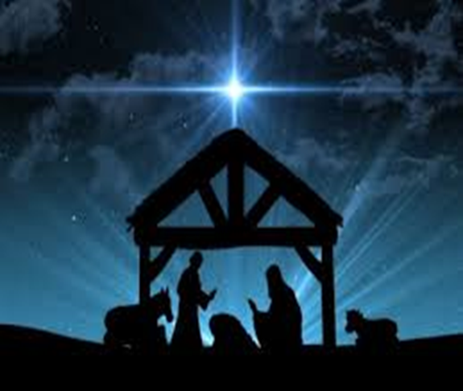

Christmas Eve prayer
December 24, 2017, evening service
Rev Lucy Bunch

Holy Spirit we come together on this night with expectant hearts, longing for love and connection, open to possibility

We draw from this ancient story,
To pray to have the courage of Mary – to face the unknown, to answer the call, and fulfill our destiny no matter what the obstacle.

We pray for the quiet strength of Joseph, to stand by those we love, to provide guidance and support in times of difficulty.

We pray to have voices like the angels – that we may call our world to greater justice, peace and good will for all.

We pray for the willingness of the shepherds – who saw the star and responded to the call of the angels by journeying far with hope and open hearts.

We pray for the graciousness of the animals – who made room in the manger and offer quiet witness to the miracle of birth.

On this most holy night, we pray for our world, that all may have what they need, all may feel safe and loved and valued.
Holy spirit fill our hearts tonight and strengthen our voices - with courage, and strength, willingness and graciousness.

O Holy spirit of love and justice, hear our prayer, on this night, on this holy night. May our spirits shine out as beacons of light in our troubled world. Amen

