UUSS FAMILY PROMISE
VOLUNTEER MANUAL

June 11-18

Guests for the week: | Room Assignment
 | #6
 | #9
 | #10
 | #12

IN CASE OF EMERGENCY:

Building: Unitarian Universalist Society of Sacramento, 2425 Sierra Blvd
Rev. Lucy Bunch – 916-396-8583

Guests: Family Promise Sacramento, Marsha Spell (916) 425-9364

Questions about volunteer duties:

Frances Myers, Co-Chair 717-682-3891  Sally Wilkins, Co-Chair 775-657-1749  Sammy Arthur, Evening Hosts 415-269-8031  Glory Wicklund, Set-up and Tear Down  916-362-4820 | Terry Nichols, Overnight Hosts  916-501-6072  Doris Janes, Meals 916-448-0966

Volunteers please sign-in – see clipboard

This manual is also online at http://www.uuss.org/familypromise/

Instructions for Family Promise-Set Up and Tear-Down
Sub-chairs
- Gary Keill, gkeill@comcast.net 916-947-8534,
- Glory Wicklund glorywicklund@comcast.net 916-362-4820
- John Merris-Michel john.merrismiche@gmail.com 916-715-7402
SET-UP – SUNDAY, JUNE 11 at 12:30 pm (right after the service)

Sub-chairs will have will have # guests & room assignments on Set-Up Day
Set-up takes (1-2 hours)
Tasks are listed in “to do”order.

Group A: Tables set up as attached: Custodians to set up tables and chairs. If not set up, please follow the diagram.
- Set up 2 tables adjoining length way; these will be used to sort bedding.
- Make sure piano is keys -facing –the-front wall by RE office.
- Get shed key, bring up high chairs and/or cribs if necessary and set them up in Fahs.
- Unload mattresses/cots and set up in guests’ rooms.
- Take cleaning supplies and dust and wipe clean window sills and counter tops.
Group B: Pull table away from cupboard near RE office
- Get out large plastic clear bags from closet .
- Take out bins of sheets, towels, and blankets.
- Put towel bin on table near front door (guests will take towels as needed).
- Get down pillows from overhead storage by kitchen.
- Set up an assembly line on the long tables: flat sheet, fitted sheet, pillowcase, 2 blankets, 1 pillow-put a set in each bag. Seal the bags (may have to lay on them to get air out).
- Take bedding bags to guests’ rooms. Any extra, store in bedding closet.
- Put empty tubs back in cupboard. Push table back against closet doors.
- Take a lamp, large flashlight, Kleenex, and small rug to each room.
Group C: Remove from cupboard near kitchen, equipment and needed items (there are 2 plug- in areas in Fahs))
- Put toiletries, Kleenex boxes, flashlights, lamps, and small rugs on table in front of entrance windows.
- Put tablecloths on tables.
- Toaster, jams, cereals and breads, – on table in front of cupboard near RE office door (plug in)
- Coffee pot and water kettle from Fahs kitchen (not stored in cupboard) – on table front wall (plug in)
- Plates, bowls, utensils, napkins, baskets of fruit – on table along kitchen wall.
- Cups and water pitchers – on table by kitchen door.
- Hot cups by coffee maker and kettle.
- Set up card table near kitchen door for sign-ins.
- Empty trash and recycling, put in new liners if necessary.

Sub-Chairs: Check all is neatly place, display any donated flowers, and check no dirty dishes.

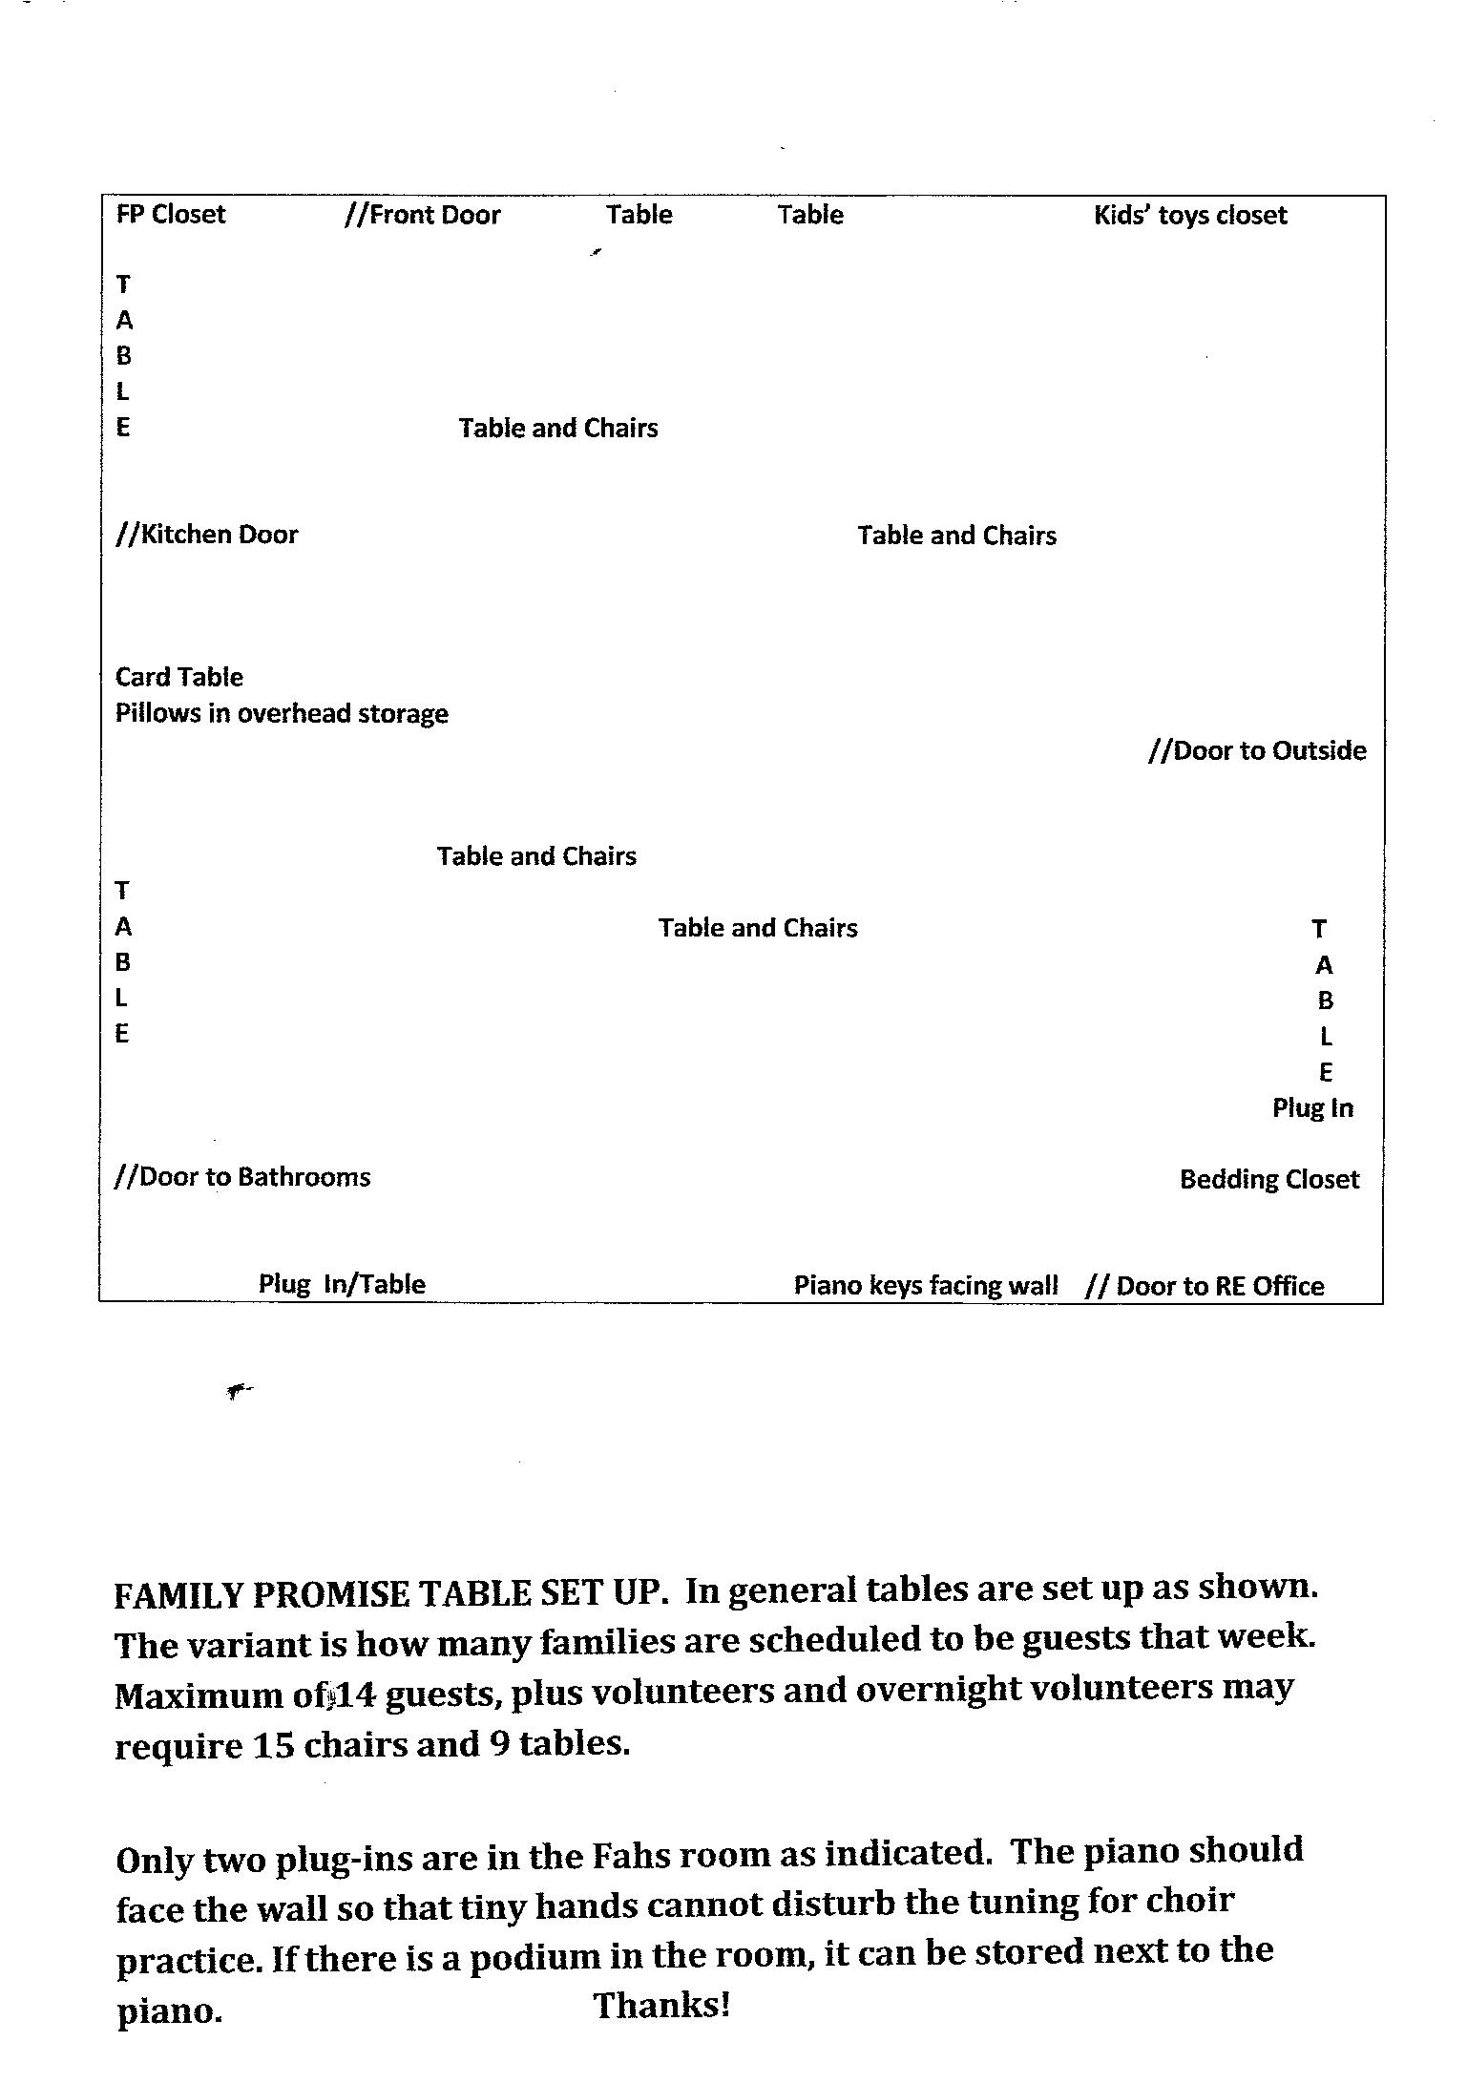
Table Set-Up Diagram

TEAR-DOWN – SUNDAY JUNE 18 at 7 am

Laundry person will organize trash bags full of laundry to be picked up by volunteers.
Group A:
- Load mattresses/beds into FP trailer.
- Take cribs and high chairs to the shed Family Promise cage. Stack in back of cage.
- Check each room for items that might have been left (flashlights, Kleenex, personal items). Make sure each room looks neat and blinds are up.
- Take tables down, store flat on wall by kitchen in front of FP closet, including the card table
- Put the piano against the wall with keys facing out.

Group B:

- Collect pillows and store in overhead cupboard.
- Wipe off toaster-- and put in cupboard by door.
- Empty coffee pot and kettle—put in Fahs kitchen by microwave.
- Take everything off tables: leave food items on table near kitchen door to be sorted, everything else (Kleenex, flashlights, etc.) store in cupboard by kitchen.
- Wash dirty dishes, dry and put away.
- Take out trash and recycling to dumpster in rear parking area. Put new liners in cans.
Group C:
- Get cart from main kitchen. Leave at Fahs kitchen door.
- Clean out refrigerator. Put on cart juices, milk and desserts to Coffee Kitchen for serving after service.
- Leftover food, give it away if someone can use it or toss (use y our judgment). Do not leave food expecting staff to want it.
- Check dishes are put away, sink and counter clean, refrig and freezer clean.
- Take soiled dish towels to main kitchen, leave in “Laundry to be Washed” bin by washer/dryer.
- Take cart to Coffee Kitchen, put juices and coffee in refrig, leave desserts on cart for Sunday Coffee people.

Sub-Chairs: Check Fahs, turn off lights, lock doors
Custodians will vacuum and mop floors.
Laundry (sheets/blankets) will be washed at home and brought back; stored in bags on floor of FP closet next to kitchen/entrance door.

EVENING HOSTING: 4:45 to 7 pm SUNDAY THRU SATURDAY
SUB CHAIR: Sammie Arthur, 415-269-8031 sfvarthur@gmail.com
Sammie will receive from Frances the names and contact info of all people hosting.
Hosting volunteers need to receive a call, text or email from Sammie a week in advance of volunteer’s hosting date. 3 days before the hosting, volunteer should be contacted again as a reminder.
VOLUNTEERS’ DUTIES:
- Arrive at 4:45pm, open FAHS room, turn on lights and heat. Sign in, sheet should be on a clip board.
- The keys are in a lock box on the utility closet door to the right of Lucy’s office, if you are in Fahs walk toward the door that leads to the bathrooms and it is on the left side. To open the lock box turn the number dial to the code provided to you via email. The four numbers should line up with small dashes on either side. Now pull down the switch/lever just to the left of the number dial. As you pull down, pull the lever out towards your body. This should open the face of the lock box towards you. The keys will be inside. If you need the code, call your sub chair (see above) or the co-chairs, phone numbers are on the front of the manual
- Check that silverware, plates, cups, and tables are ready for guests.
- Put out water and/or juice in pitchers and pull out any serving utensils.
- Check that both bathrooms are clean and presentable and that they have paper towels and toilet paper and soap.
- Make coffee (we’ll have decaf and regular)
- Open rooms, check they’re presentable, Return keys to the lock box after all rooms are opened
- Greet guests as they arrive. The guests will arrive between 5 and 5:30, they will be in the Family Promise van. At this time the Family Promise staff will be give you the locked medicine box and the binder with information, feel free to ask questions.
- When dinner people arrive, help them put food out and supervise servings. You may need to flag down the volunteer cooks in the parking lot if they don’t find the Fahs room.
- Enjoy a meal with the family promise participants.
- Encourage guests to clear their own dishes and rinse silverware, etc.
- After dinner, the kitchen needs to be cleaned up and food put away and tables need to be cleaned off. If you notice that we need any food, paper or cleaning supplies, please make a note of it there will be a place for notes/suggestions on the clipboard with the sign-in sheets.
- LABEL ALL LEFTOVERS AS FAMILY PROMISE WITH CONTENTS AND DATE!
- After dinner, read to children /or play games
- Check the blue box and dispense meds as needed. (Always keep the box locked)
- When overnight hosts arrive, walk them through the process of meds, lock box, etc. Wait for overnight hosts to arrive before departing. If overnight hosts will be late the committee should have made arrangements, feel free to call the co-chairs is the no-one has come by 7:30.
- If you have any issues/concerns about the families, emergency call the case worker on the front sheet, if it’s not an emergency please make a note of it, there will be a place for notes/suggestions on the clipboard with the sign-in sheets.
FOR BOTH LEGAL AND SAFETY CONCERNS, IT IS IMPORTANT THAT THE PARENTS ARE IN THE FAHS ROOM WITH KIDS WHENEVER VOLUNTEERS ARE ENGAGING THE KIDS. DO NOT EVER BE ALONE WITH THE CHILDREN.

OVERNIGHT VOLUNTEERS: 2 per night, arrival time is: 7 pm to 7 am the following morning.
Sub Chair – Terry Nichols 916-501-6072
DUTIES:
- Arrive by 7 pm, if you need to arrive later, let us know and we will make arrangements for someone to be there until you can arrive. Please sign in, sheet will be on a clip board.
- The keys are in a lock box on the utility closet door to the right of Lucy’s office, if you are in FAHS walk toward the door that leads to the bathrooms and it is on the left side. To open the lock box turn the number dial to the code provided to you via email. The four numbers should line up with small dashes on either side. Now pull down the switch/lever just to the left of the number dial. As you pull down, pull the lever out towards your body. This should open the face of the lock box towards you. The keys will be inside. If you need the code, call your sub chair (see above) or the co-chairs, phone numbers are on the front of the manual
- Bring your own sleeping bag, pillow and pad. (The cots aren’t very comfortable) Cots will be in the FAHS room for you.
- Go over guests’ meds with hosting volunteer. Dispense, if necessary, and be sure medical box is locked and put into kitchen
- Check that kitchen is cleaned up and dishes are washed and put away.
- About 10 pm, take a walk around campus and be sure all is well.
- In the morning, make coffee about 6 am and be sure all families are up and moving.
- Have breakfast food readily available: cereal, coffee, juice, milk, etc. Be sure toaster is out and plugged in
- After families have left, straighten FAHS room, lock guests’ doors, and unplug/turn off all appliances. Be sure all food is put away. If you notice that we need any food, paper or cleaning supplies, please make a note of it there will be a place for notes/suggestions on the clipboard with the sign-in sheets.
- Check bathrooms and restock if necessary.
- Lock FAHS on the way out.
- Check lockbox and be sure it’s locked with keys in it
- If you have any issues/concerns about the families, emergency call the case worker on the front sheet, if it’s not an emergency please make a note of it, there will be a place for notes/suggestions on the clipboard with the sign-in sheets.

FOR BOTH LEGAL AND SAFETY CONCERNS, IT IS IMPORTANT THAT THE PARENTS ARE IN THE FAHS ROOM WITH KIDS WHENEVER VOLUNTEERS ARE ENGAGING THE KIDS. DO NOT EVER BE ALONE WITH THE CHILDREN.

DINNER PROVIDERS:
Sub-Chair Doris Janes 916-448-0966
- There will be 2 – 3 volunteers each night providing the:
  - Main Course
  - Veggie or Salad
  - Dessert
- Your committee chair will contact you the week before families arrive to let you know how many people you’ll cook for, and will provide suggestions for menu ideas if necessary.
- Arrive at 5:45 pm with dinner hot and ready to go. Please sign in, sheet will be on a clip board.
- Feel free to stay and eat with the families if possible.
- Transfer food to our platters and/or refrigerator dishes so that you can take your dishes home with you. It’s much easier for us if you do so.

Suggestions for Meals
Simple and kid friendly
Desserts – fruit, cookies, ice cream

